**TASK 05**

1. Qdrant configured and installed on local system. Few test collections were created for practice and Demo collection (generic-collection) created.

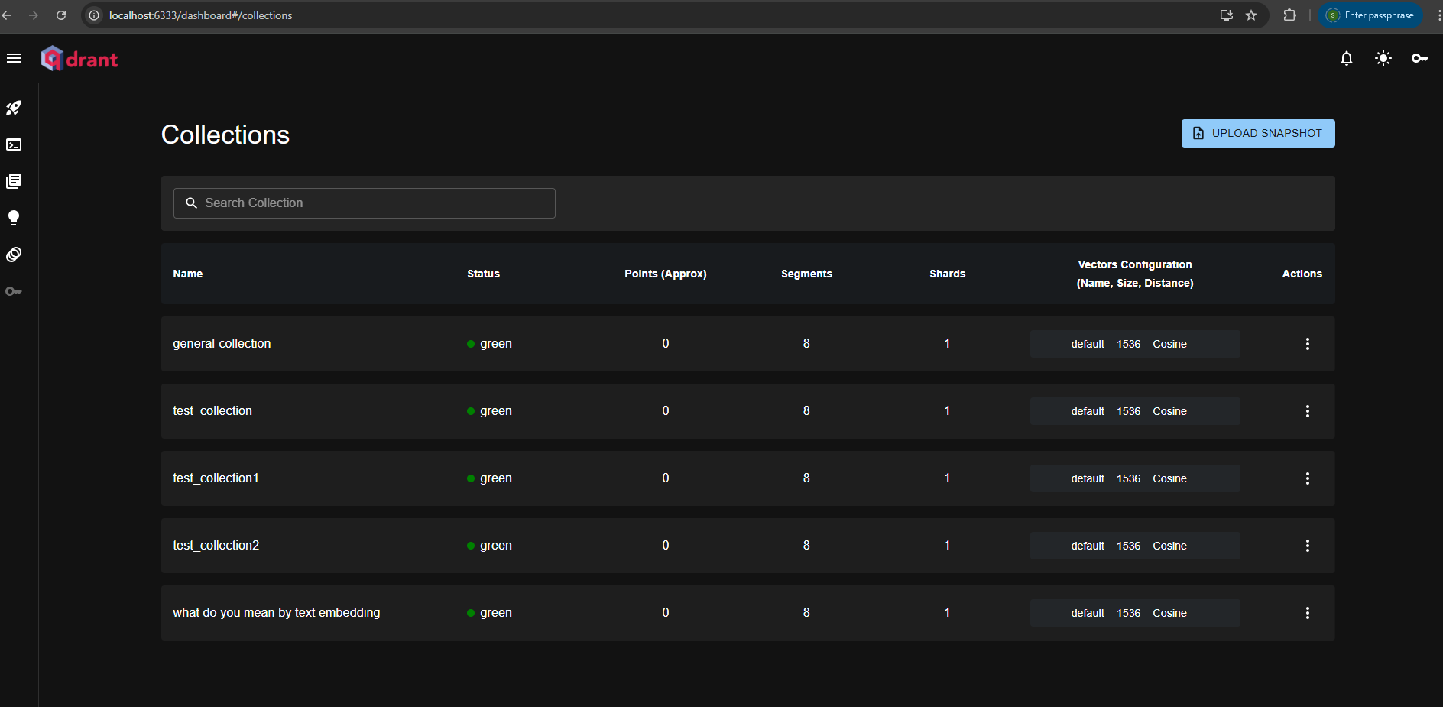

1. Create Embeddings for given text

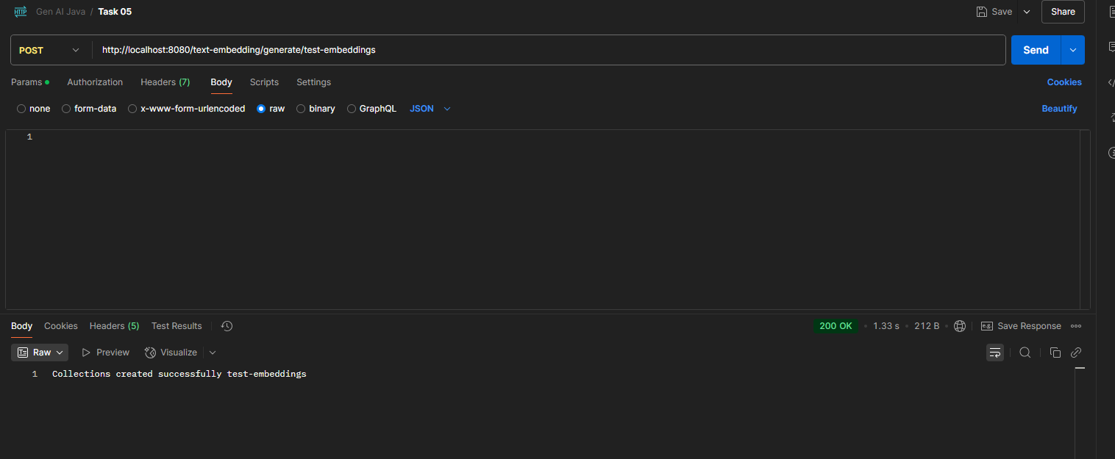

Collection created in local Qdrant with vector information.

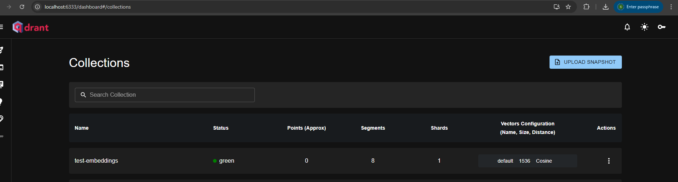

1. Retrieve Embedding

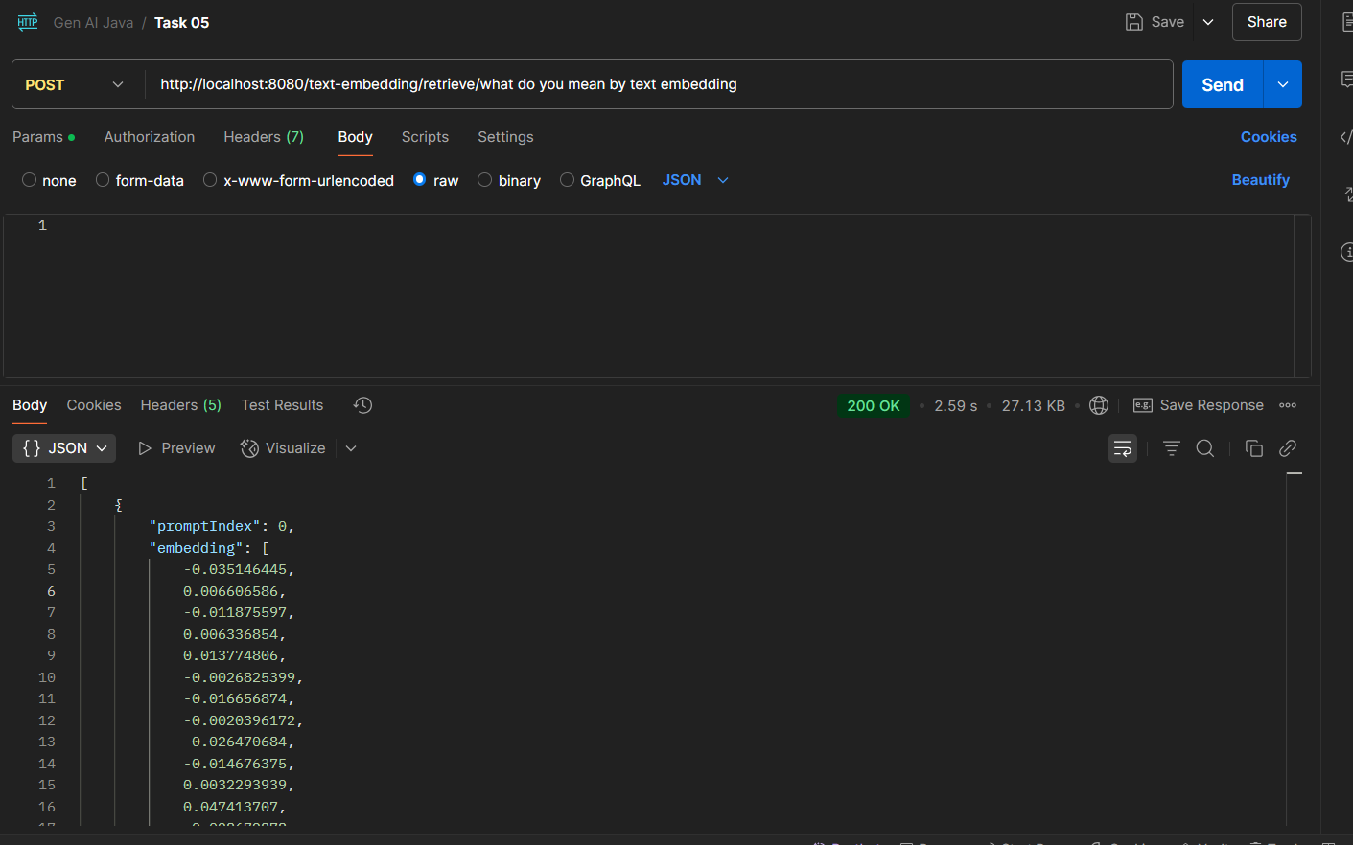

1. Store Embedding

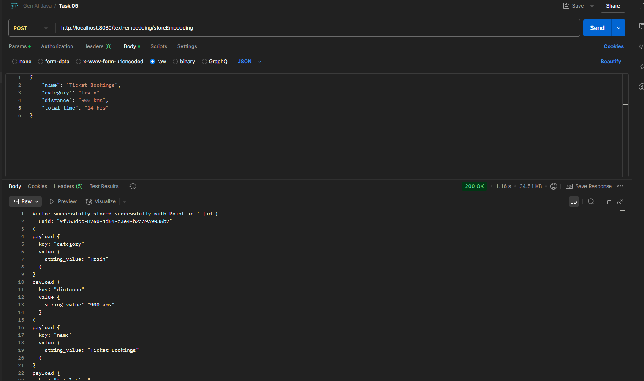

Saved Embedding to Qdrant.

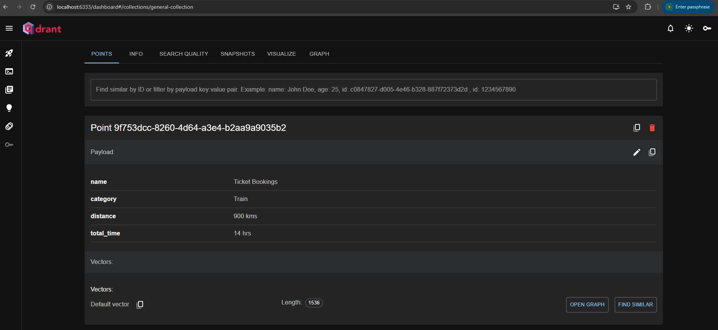

1. Search Embeddings:

Observations: If we provide a prompt that resembles slightly with the data in the embeddings, we created in above steps the score is higher in the response.

In below screenshot, the prompt is unrelated to the data in the embeddings, still the service was able to relate that the film is related to movie and returned it as top response.

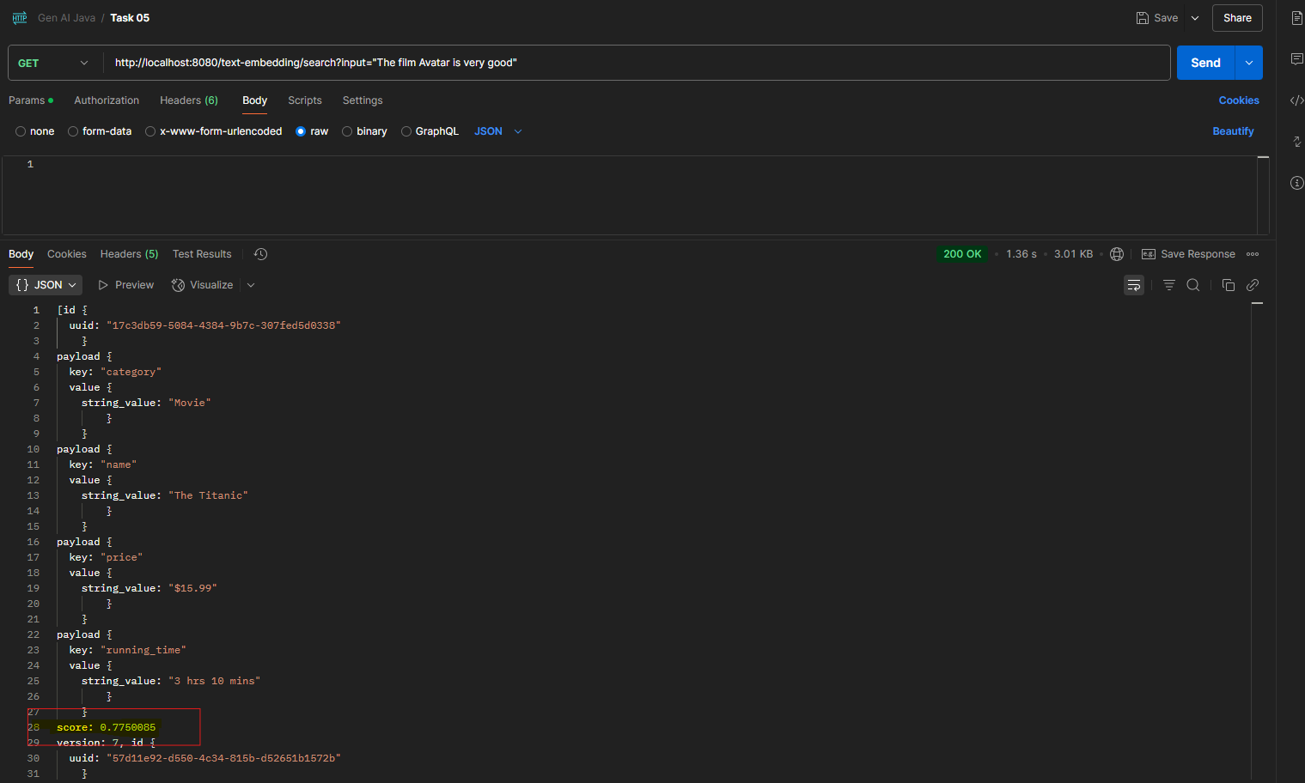

When a film that is already in the embedding is provided as prompt, the service returns it as a top match for the search.

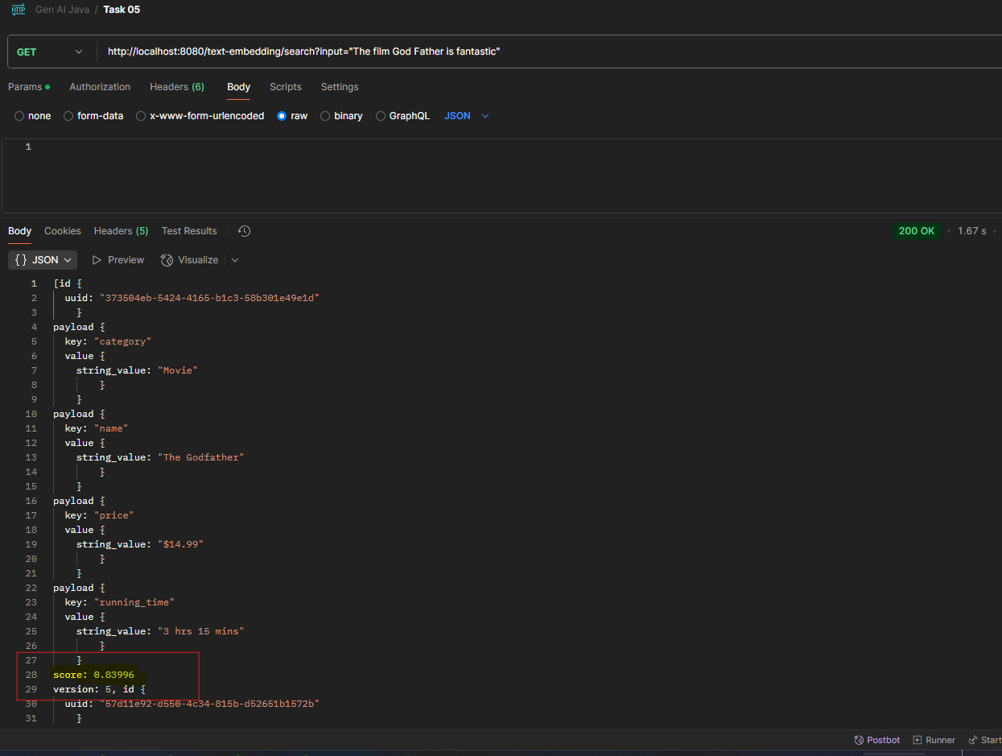

When the prompt is changed to ask a travel response, the search response returns a train travel response which is the closest embeddings match we have in our embeddings.

